Objective Questions:
- What is the total number of attributes in the customer table?
- The Customer Table includes 3 following attributes:
- CustomerID: A unique identifier for each customer.
- Customer Age: The age of the customer.
- Customer Gender: The gender of the customer (M for male, F for female).
- How will you get the “Customer’s” ages in the “Order” tables according to customer IDs?
- Enter the following formula in the Order Table:
CustomerAge = RELATED(Customers[Customer Age])
- In analyzing the dataset with Power BI, ensure data cleaning to address inconsistencies and missing values before further analysis.
- In Power BI, we use Power Query Editor to:
- Removing duplicates.
- Handling blank rows by removing it.
- Ensuring data types are correct.
- How can we calculate the total revenue generated by all the sales?
- Enter the following DAX formula:
TotalRevenue = SUM(Orders[Sale Price])
- What is the total number of unique customers who made purchases each year? Is there any increase in the number over the years?
- Create Measure for UniqueCustomers Per Year in Orders Table
Enter the following DAX Formula :
UniqueCustomers = DISTINCTCOUNT(Orders[CustomerID])
Establish relationship between:
Calendar[Date] 1 ────> * Orders[Order_Date]
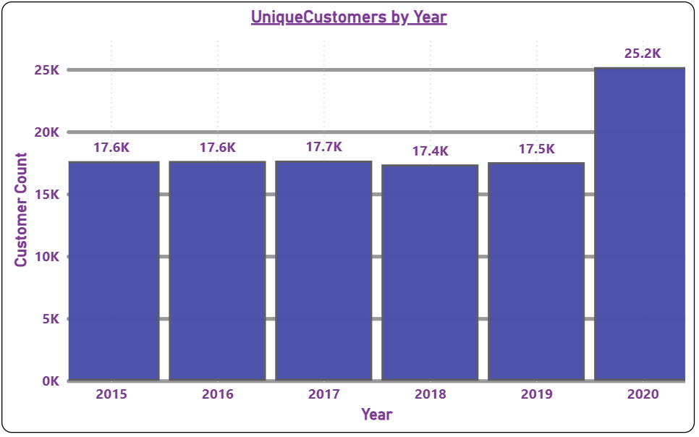
- How can we determine the total number of unique products available in the company?
- Enter the following DAX Formula :
TotalUniqueProducts = DISTINCTCOUNT(Orders[Product])
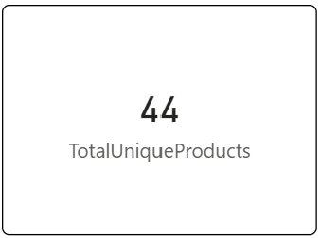
- What is the average number of days it takes for products to be delivered, get the metric for only the delivered orders.
- Followed below steps:
  - Created a New Column for Delivery Duration
  - Enter DAX Formula :
WaitingTime = DATEDIFF(Orders[OrderDate],Orders[Delivery Date],DAY)
  - This formula calculates the number of days between the OrderDate and Delivery Date.

  - New Measure
  - Enter the DAX formula:
AvgDaysForDeliveredProduct = CALCULATE(AVERAGE(Orders[WaitingTime]),Orders[Status]="Delivered")
  - This measure calculates the average delivery duration for orders where the status is "Delivered."
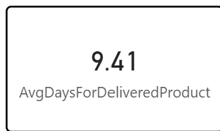

- Which products, categories, and subcategories are the most popular?
- Popularity by Order Quantity:
- New Measure :
TotalOrderQuantity = SUM(Orders[Order Quantity])

- For Most Popular Products:

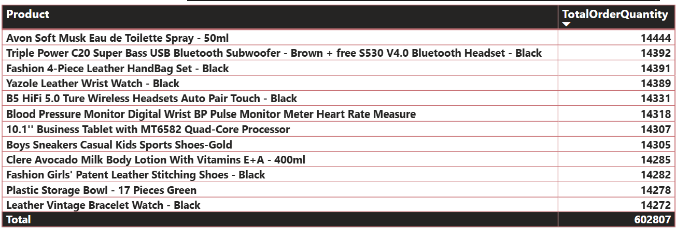

- For Most Popular Categories:

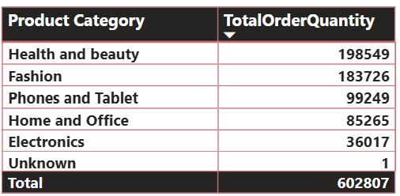

- For Most Popular Sub-Category:

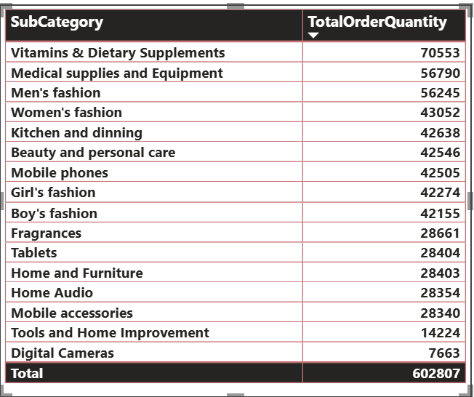
- Which products have seen an increase or decrease in sales over the year?

- While modeling the data relationships, what will be the type of relationship between the customer ID of Orders and customer tables?

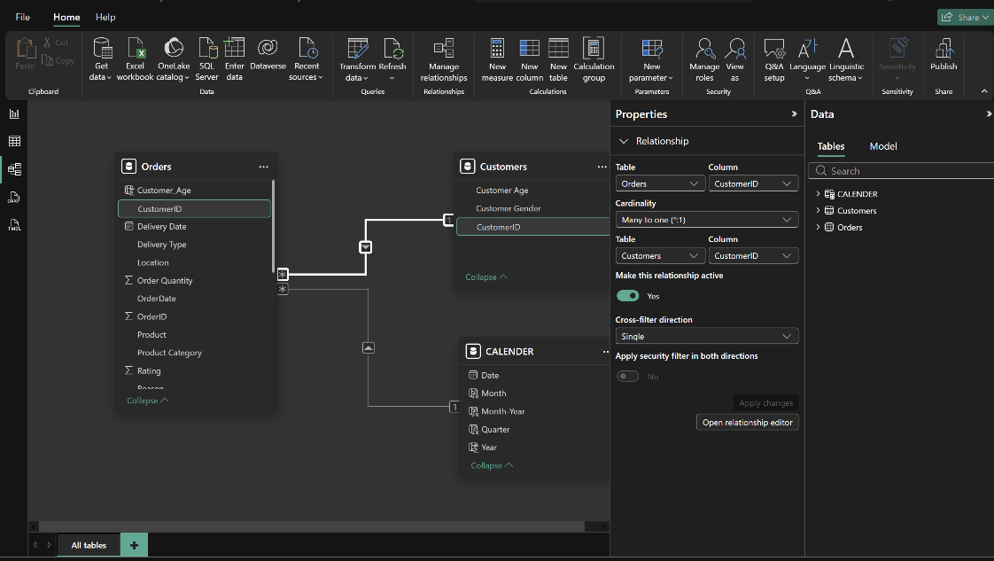
The type of relationship between the customer ID of Orders and Customer table is “one to many” relationship.

- How have you handled the null values in the data?
- Using Power Query Editor to Filter or Remove Null Values
- Go to Power BI Desktop
- Click on Transform Data
- Select the column where I’ve to handle null values
- Click on the Filter Dropdown
- If null values exist, then uncheck "(null)" in the filter
- This removes rows containing null values
- Handling Blank Values Using DAX
- Open Power BI Report View
- Click on the "Modeling" tab
- Click New Measure
- Create a DAX Measure for Null Handling.
- Used "NA" in categorical fields like Reason where blanks occurred, ensuring no column remains empty.
- Removing Blank Rows
- In Power Query, select the dataset
- Click on Transform > Go to Row o Check if there are any fully blank rows
- Click Remove Rows > Remove Blank Rows
- This removes any row where all columns are blank

- Were there any data format issues in the data, and if there were/are how you would handle them?
- In our data, there was no need to change the data types. If there was such an issue to format the datatypes then I can check and transform data types in the Power Query editor.
- When we add a column in Power Query what’s the code that comes in M language in the formula bar? What do you know about M-query?
- M Query is the functional language used in Power Query to transform and prepare data before loading it into the Power BI data model. When we add a column in Power Query, Power BI generates M query that reflects the action.

Example of M Code for Adding a Column:
= Table.AddColumn(Source, "NewColumnName", each [ExistingColumn] * 2, type number)

- Identify the top 5 most valuable customers using a composite score that combines three key metrics: (SQL)
  - Total Revenue (50% weight): The total amount of money spent by the customer.
  - Order Frequency (30% weight): The number of orders placed by the customer, indicating their loyalty and engagement.
  - Average Order Value (20% weight): The average value of each order placed by the customer, reflecting the typical transaction size.
- The Composite Score will be calculated as:
=(0.5×Total Revenue)+(0.3×Order Frequency)+(0.2×Average Order Value)

Query:

select distinct CustomerID,sum(SalePrice) as TotalSales,
count(OrderID) as Frequency,avg(SalePrice) as AvgValue,
(0.5 * sum(SalePrice) + 0.3 * count(OrderID)+ 0.2 * avg(SalePrice)) as CompositeScore
from orders
group by CustomerID
order by CompositeScore desc
limit 5;

The top 5 valuable customers as follows:

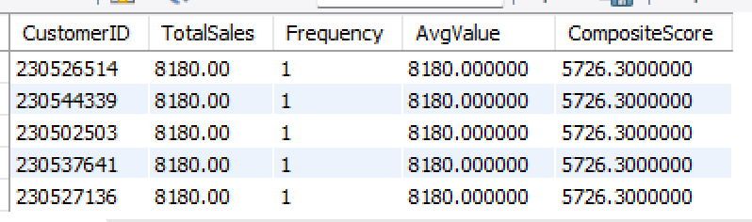

- Calculate the month-over-month growth rate in total revenue across the entire dataset. (SQL)
- Query :

with MonthlyRevenue as
(
select year(OrderDate) as 'YEAR',month(OrderDate) as 'MONTH',sum(SalePrice) as TotalSales
from orders
group by year(OrderDate),month(OrderDate)
)
select *,
(TotalSales - lag(TotalSales) over (order by YEAR ,MONTH))/
(lag(TotalSales) over (order by YEAR,MONTH) )*100 as MoMGrowthRate
from MonthlyRevenue;

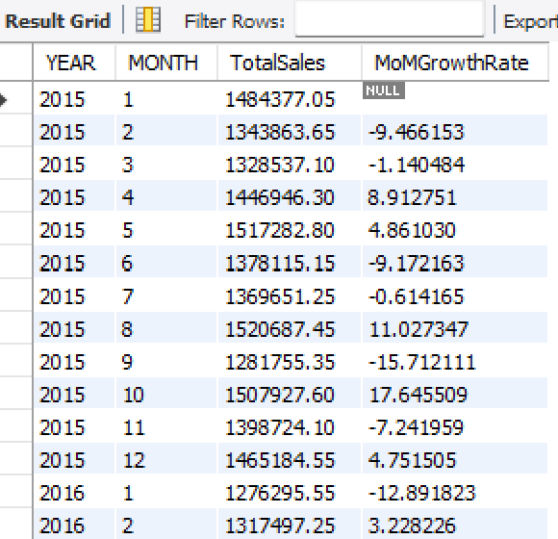

- Calculate the rolling 3-month average revenue for each product category. (SQL)
- Query :
with RollingAvg as
(
select distinct coalesce(nullif(ProductCategory, ''), 'NA') AS ProductCategory ,year(OrderDate) as 'YEAR',
month(OrderDate) as 'MONTH',sum(SalePrice) as TotalRevenue
from orders
group by ProductCategory,YEAR , MONTH
order by YEAR , MONTH
)
select *,
avg(TotalRevenue) over(partition by ProductCategory order by YEAR,MONTH
rows between 2 preceding and current row) as 3DayRollingAverage
from RollingAvg;

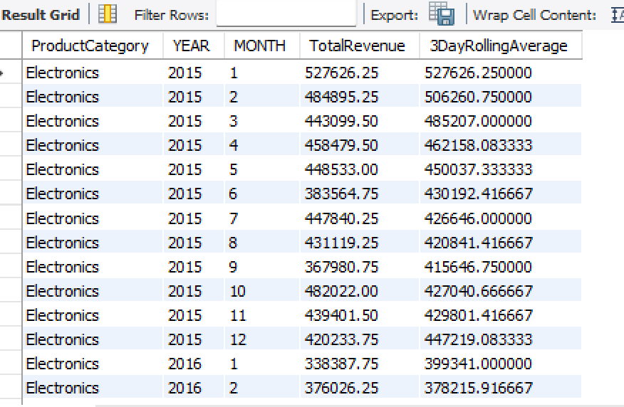

- Update the orders table to apply a 15% discount on the `Sale Price` for orders placed by customers who have made at least 10 orders. (SQL)
- Query :
update orders
set SalePrice = SalePrice * 0.85
where CustomerID in (
select CustomerID from orders group by CustomerID
having count(OrederID) > = 10
);
- Calculate the average number of days between consecutive orders for customers who have placed at least five orders. (SQL)
- Query :
with NxtOrders as
(
select CustomerID,OrderID,OrderDate,
lead(OrderDate) over(partition by CustomerID order by OrderDate) as NxtOrderDt
from orders
)
select CustomerID,
avg(datediff(NxtOrderDt,OrderDate)) as AvgDaysBtwOrders
from NxtOrders
where NxtOrderDt is not null
group by CustomerID
having count(OrderID) >=5;

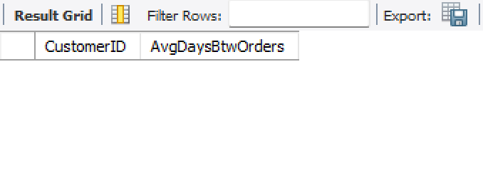
- Identify customers who have generated revenue that is more than 30% higher than the average revenue per customer. (SQL)
- Query :
select CustomerID,sum(SalePrice)as TotalRevenue
from orders
group by CustomerID
having TotalRevenue >
(
select avg(SalePrice)*1.30 from orders
);
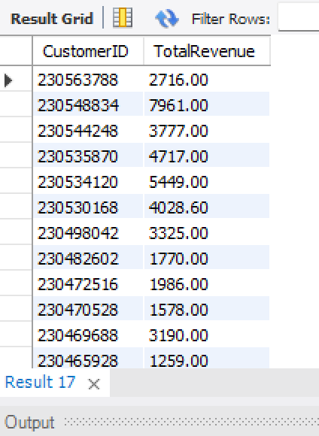
- Determine the top 3 product categories that have shown the highest increase in sales over the past year compared to the previous year. (SQL)
- Query :

with CurrentYear as
(
select ProductCategory,sum(SalePrice) as CurrentYrTotalSales
from orders
where year(OrderDate)=(select max(year(OrderDate)) from orders)
group by ProductCategory
)
,PreviousYear as
(
select ProductCategory,sum(SalePrice) as PreviousYrTotalSales
from orders
where year(OrderDate)=(select max(year(OrderDate))-1 from orders)
group by ProductCategory
)
select c.*,p.PreviousYrTotalSales,
c.CurrentYrTotalSales - p.PreviousYrTotalSales as SalesIncrease
from CurrentYear c join PreviousYear p
on c.ProductCategory = p.ProductCategory;

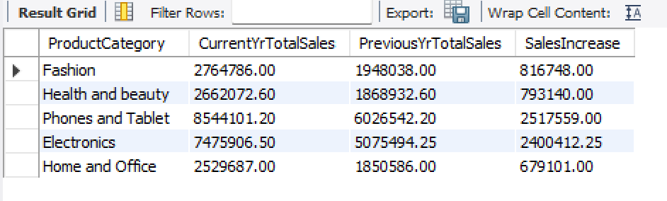

Subjective Question:
- Explain the revenue breakdown by year and by-product. Evaluate how different products contribute to annual revenue and come up with suggestions to increase the sales of the low-selling items.

Revenue breakdown by year:
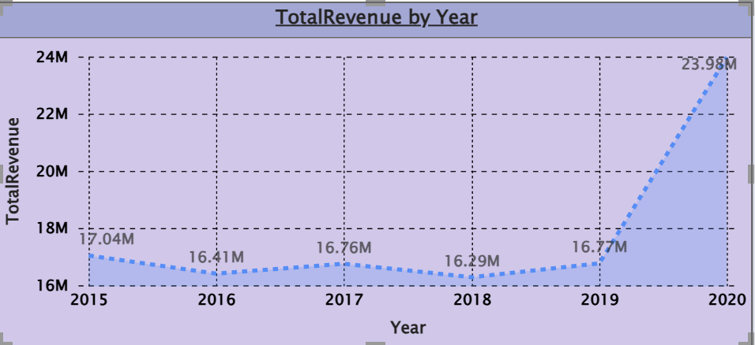

Revenue breakdown by product:
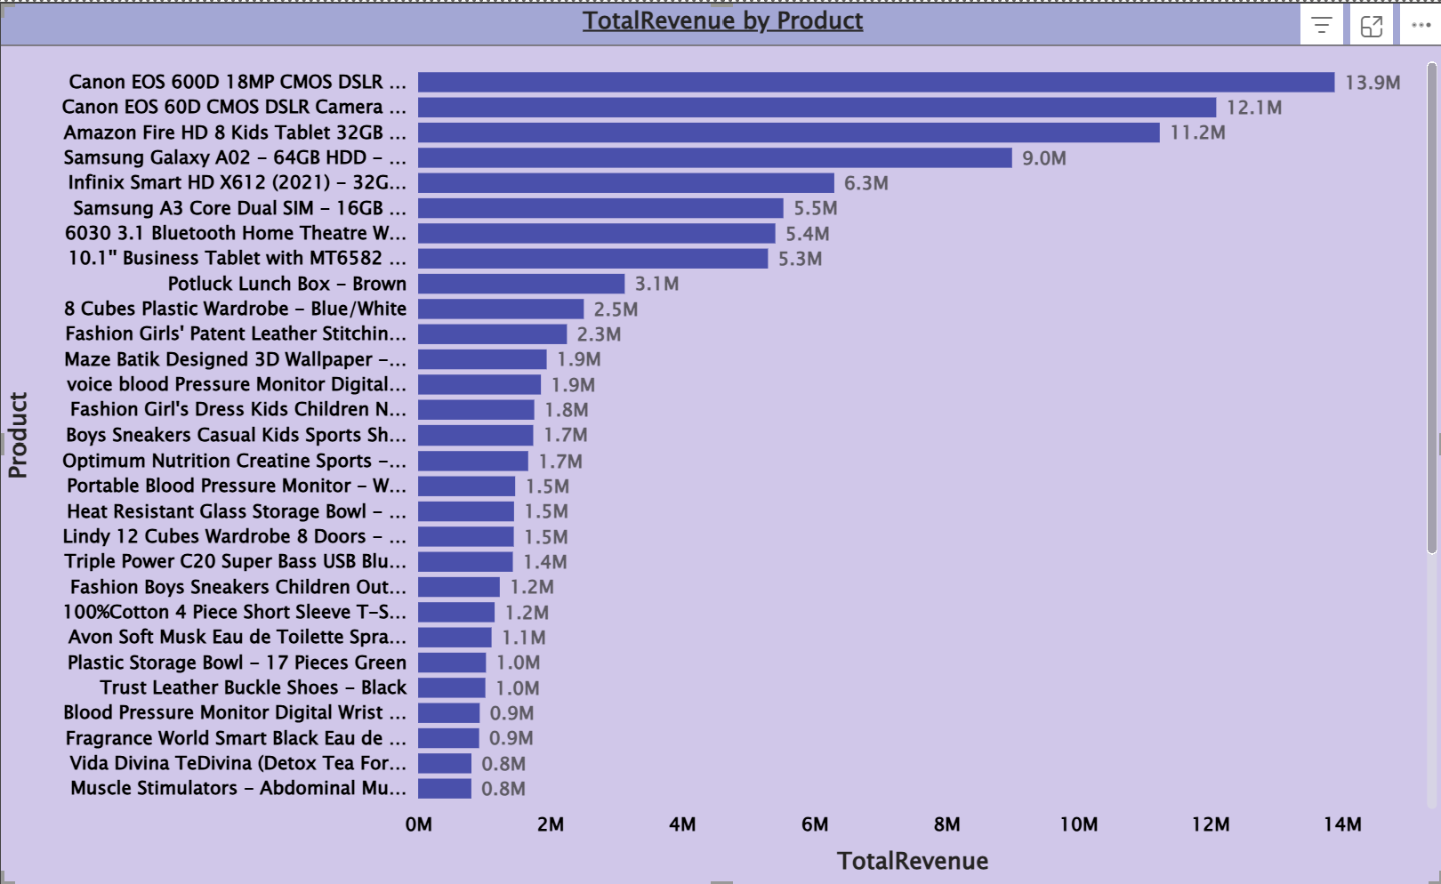

Strategies to Increase Sales of Low-Selling Items:
  - Combine low-selling products with top-performing items as part of a bundle deal.
  - Provide special discounts on low-selling items for a limited time to boost demand.
  - Place low-selling products in the "Recommended for You" or "Trending Now" section.
  - Compare pricing with competitors and adjust accordingly.
  - Retarget interested customers who viewed but didn’t purchase low-selling products.

- How many products were returned? Use a DAX function to get this metric. Examine the possible reasons for returns and consider how this metric could indicate improvements in product descriptions or quality control.
- Measure for counting no. of Returned Products:
CountOfReturnedProducts = COUNTROWS(FILTER(Orders,Orders[Status] = "Returned"))
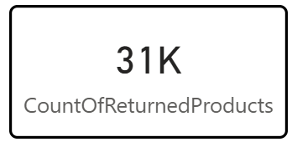

Analyse Reasons for Returns:
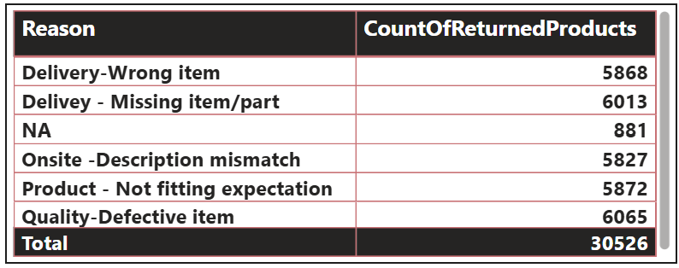
Insights from the data to Examine the possible reasons for returns and consider how this metric could indicate improvements in product descriptions or quality control:
- Delivery - Wrong Item
Issue:
  - Incorrect products are being sent, possibly due to warehouse mislabelling or human error.
Solution:
  - Improve order verification systems before shipment.
  - Introduce a "Live Order Check" where customers can confirm their order before shipment.
- Delivery - Missing Item/Part
Issue:
  - Items with missing parts indicate incomplete packaging or supply chain issues.
Solution:
  - Add checklists at packaging stations to confirm completeness.
  - Implement barcode scanning to verify that all required parts are included.
  - Add checklists at packaging stations to confirm completeness.
- Onsite - Description Mismatch
Issue:
  - Customers are getting items that do not match what was shown online.
Solution:
  - Cross-check product listings with actual items before listing.
  - Require vendors to submit real customer photos instead of only stock images.

- Product - Not Fitting Expectation
Issue:
- Customers return items because they don’t match their expectations, possibly due to misleading descriptions or images.
Solution:
  - Improve product descriptions by including detailed specifications.
  - Use high-quality images & 360-degree product views.
  - Add customer reviews and Q&A sections to clarify doubts.
  - Provide a "Size Guide" or "Comparison Tool" for apparel and electronics.

- Quality - Defective Item
Issue:
  - “Quality-Defective Item” (6,065) is the most common reason for returns.
  - Faulty manufacturing or improper handling may be leading to damaged goods.
Solution:
  - Implement stricter quality checks before shipping.
  - Use AI-driven quality control in warehouses to detect product defects.

- Whenever a customer goes to Amazon, they’ll filter the most rated products to buy the better category. Can you verify this using any visualization or table that the ratings of products impact their sales value?

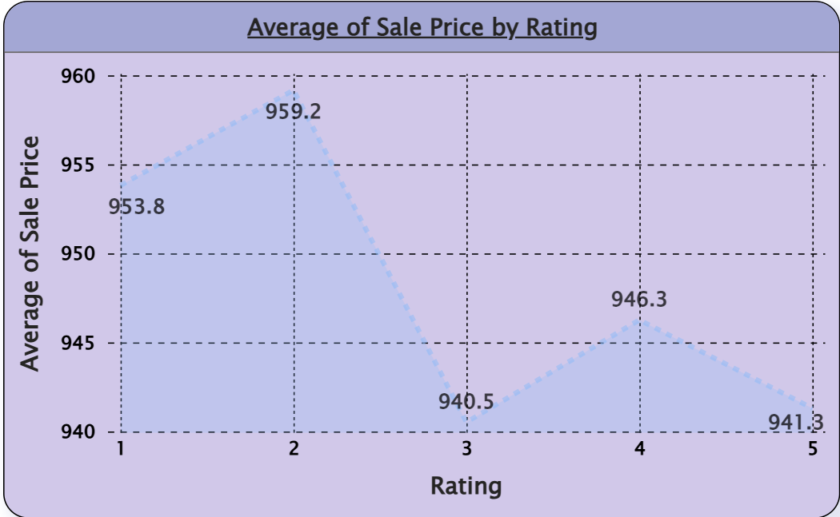

Insights:
- Highest average sale price at Rating 2 (~959)
- Lowest average sale price at Rating 3 (~940)
- Ratings 1 and 2 outperform higher ratings in sale price
- No linear relationship between rating and sale price
Recommendations:
- Review Rating 3 products – identify quality gaps or pricing issues
- Leverage Rating 2 products – analyse and replicate across other products
- Reassess pricing for high-rated products (4–5)
- Collect customer feedback to understand rating-price mismatch

- Investigate how revenue distribution varies across different locations. Explore which geographical areas contribute most to sales and consider the strategic implications for regional marketing and distribution efforts. How might location-based trends inform the company's market segmentation and resource allocation approach?

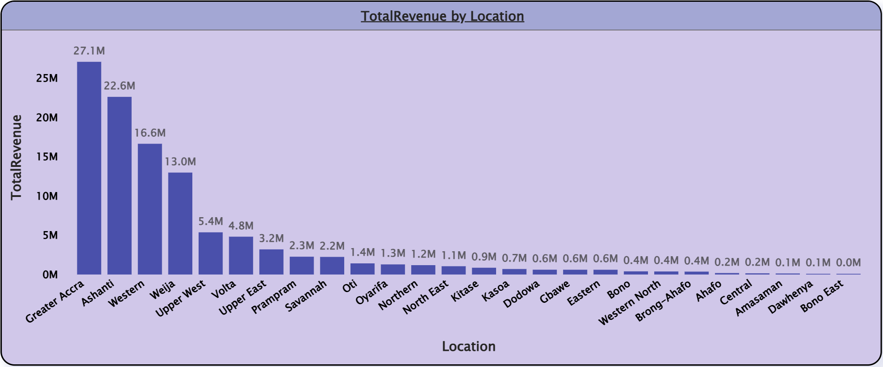

Insights and Targeted Marketing Strategies:
- Greater Accra stands out as the highest revenue-generating region with 27M. This suggests that it is a critical market for business.
- Other contributors like Upper West and Eastern regions also generate significant revenue, indicating multiple strong markets.
- Areas from Oti show relatively low revenues as shown above. This highlights potential areas for improvement or targeted marketing efforts.
- Location-based trends can significantly inform a company's market segmentation and resource allocation strategy in several ways:
- By analysing revenue data by location, the company can identify which regions contribute the most to overall sales.
- Variations in purchasing behaviour across locations can lead to the development of localized versions of products or services to better meet customer expectations.
- Understanding geographical revenue distribution can help in planning logistics and distribution strategies, ensuring that high-demand areas are well-stocked while optimizing inventory levels in less productive regions.

- Determine which month could benefit from enhanced promotional offers to boost sales. Can you suggest some targeted marketing strategies here?

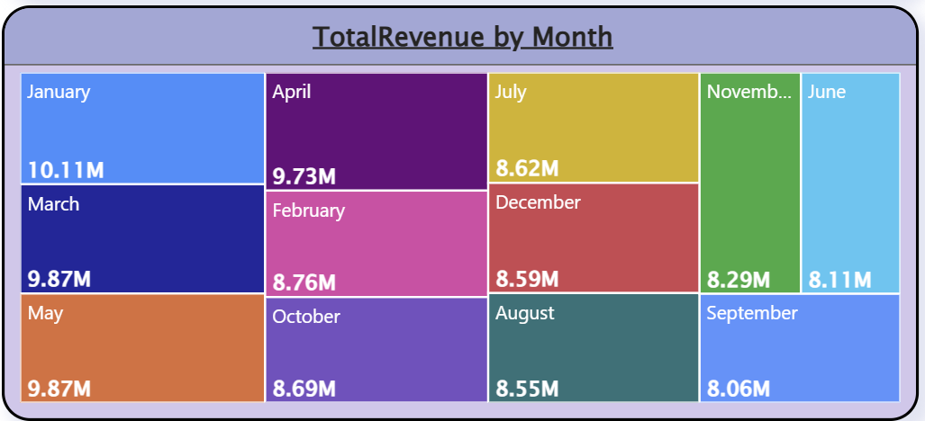

Insights:
- January (10.1M) has the highest sales and doesn't require boosting.
- June(8.1M), September(8.06M) and November(8.29M) represent sales dip below the average(9M) and should be targeted for enhanced promotions.
- July, August, October, and December show consistent but lower-than-ideal sales that can benefit from specific seasonal promotions.
Targeted Marketing Strategies:
- Discount & Cashback Offers:
- Offer higher discounts on slow months.
- Implement limited-time cashback offers to encourage spending.
- Prime Membership Incentives:
- Provide extra perks for Prime members, such as free express delivery in low-sales months.
- Offer exclusive early access to deals.
- Personalized Promotions:
- Use customer purchase history to send customized discount coupons.
- Offer bundle deals based on customer preferences.
- Festive & Event-Based Marketing:
- Align promotions with local festivals or shopping holidays.
- Like November and December Focusing on Black Friday, Diwali gift deals, "12 Days of Christmas" offers.
- Identify which products may require increased marketing efforts. Which items have high prices yet underperform in sales?

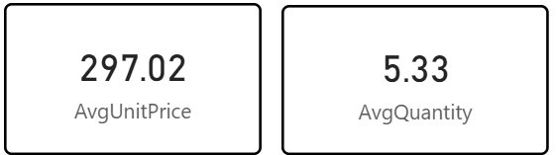

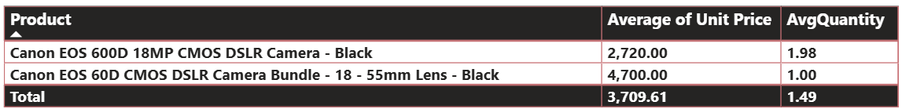
Approach:
Products with unit prices higher than the overall average but lower-than-average sales quantities were identified as underperformers. These items likely require increased marketing efforts or pricing strategy adjustments to improve sales performance.
Insights:
- There were two products identified.
- Canon EOS 600D 18MP CMOS DSLR Camera - Black:
- Canon EOS 60D CMOS DSLR Camera Bundle with 18-55mm Lens - Black:
- Some high-priced products are selling in lower quantities, indicating weak demand despite premium pricing.
- Price alone is not driving sales; customer perception or value may be misaligned.
- These products are potential candidates for marketing or pricing review.

Recommendations:
- Increase targeted marketing and promotions to better communicate the value of high-priced, low-selling products.
- Review pricing strategy (discounts, bundles, offers) to improve affordability and demand.
- Enhance product positioning through better descriptions, ratings, or visibility to build customer trust.

- Assess which products should have discounts. How can targeted incentives drive sales and customer loyalty for specific products?

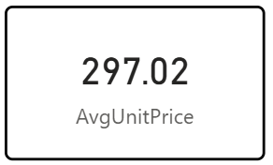
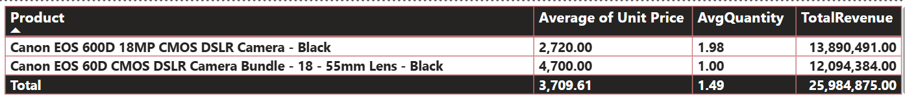

Approach:
Products with unit prices higher than the overall average were filtered out to ensure that there is enough pricing margin for potential discounts without compromising profitability.

Insights:
- Both products have low sales volumes but still generate significant revenue, indicating strong potential if sales volume is improved.

Recommendations:
- Offer targeted discounts or bundle offers to attract new customers while maintaining profit margins.
- Create urgency by offering limited-time deals and festive promotions.
- Combine discounts with loyalty rewards or future purchase vouchers to increase repeat sales.
- To generate interest, launch targeted marketing campaigns aimed at photography enthusiasts and semi-professionals.

- Come up with a loyalty program to benefit the company’s customers. From the available lot of customers come up with strategies to bucket them and provide benefits under different loyalty programs.

The goal of this loyalty program is to increase customer retention, boost repeat purchases, and enhance customer satisfaction by offering tailored benefits. To do this, created different loyalty tiers based on purchase behaviour.

To categorize customers, used three key factors:
• Purchase Frequency (How often a customer buys)
• Total sales
• Order quantity
• Customer Rating

Using this, divided customers into four loyalty tiers:
- Platinum Tier (High-Value Customers)
Criteria:
- 8-10 orders per month.
- High total sales (Top 10% of all customers)
- Low return rate and high customer ratings.
Benefits & Strategies:
- Free Next-Day or Express Delivery
- Personalized Product Recommendations
- Extra Cashback (5%–10%)
- Exclusive Early Access to Sales
- Gold Tier (Frequent Buyers)
Criteria:
- 5-7 orders per month
- Moderate to high total spend
- Occasional returns, decent customer ratings High total sales (Top 10% of all customers)
Benefits & Strategies:
- Loyalty Coupons (like some amount off on purchases above)
- Bonus Points on Special Events (festivals, birthdays, etc.)
- Refer & Earn Program (₹200 credit for bringing new customers).

- Silver Tier (Occasional Shoppers)
Criteria:
- 2–5 orders per month
- Medium spending pattern
Benefits & Strategies:
- Limited-Time Discount Offers
- Free Shipping on Orders Above some amount.
- Offer 1-month free trial of Prime-membership to convert them into loyal customers.
- Basic Tier (Inactive Buyers)
Criteria:
- Only 1 purchase in the last 3–6 months
- Low engagement, minimal spending
Benefits & Strategies:
- Welcome Back Discount (Some amount Off on Next Order)
- Email / SMS Campaigns with Personalized Deals
DAX Query:
Customer_Segment =
SWITCH(
TRUE(),
[TotalRevenue] >=6000,"Platinum",
[TotalRevenue] >=3000,"Gold",
[TotalRevenue] >=1000,"Silver",
"Bronze"

)

Insights:
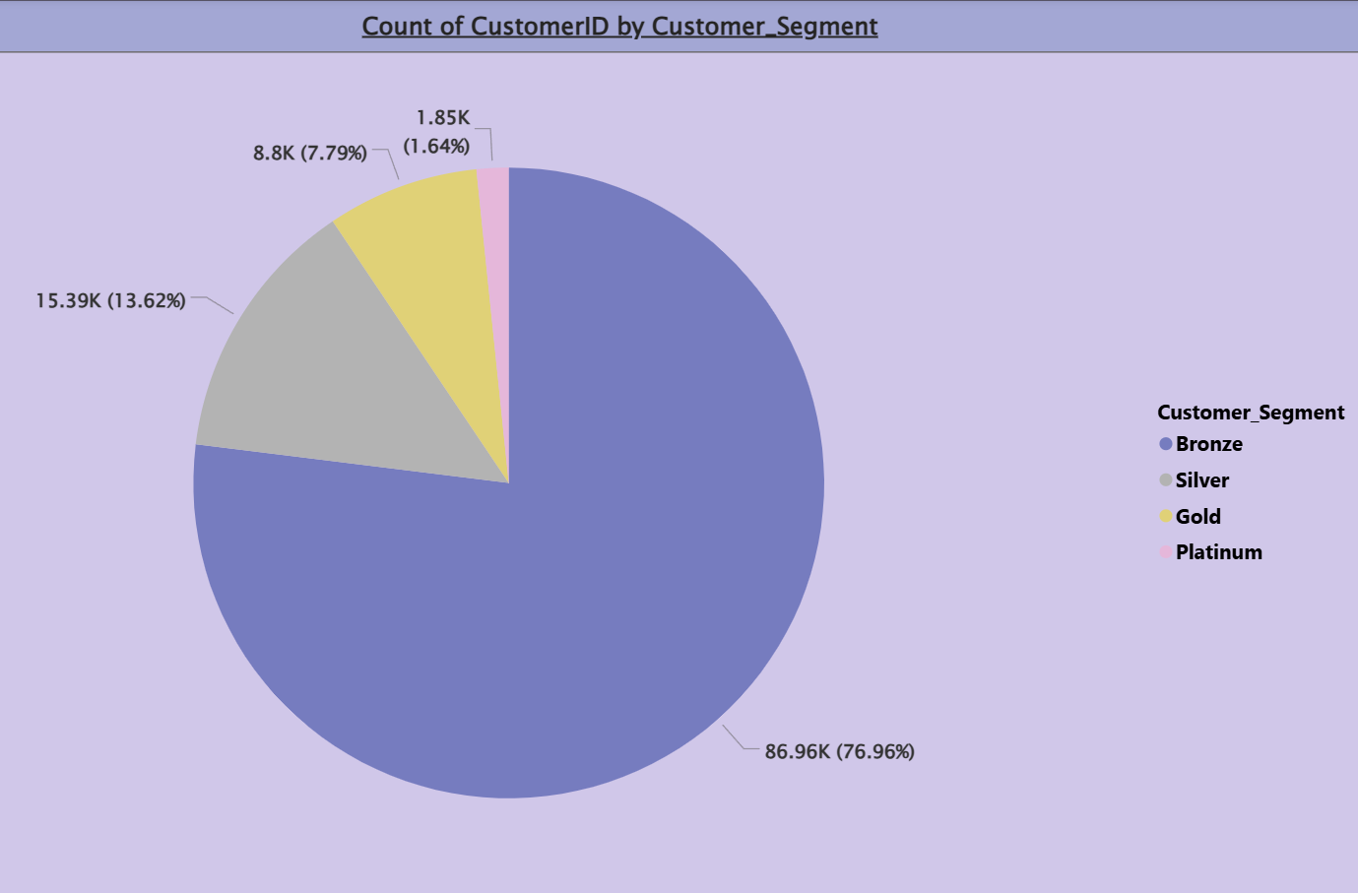
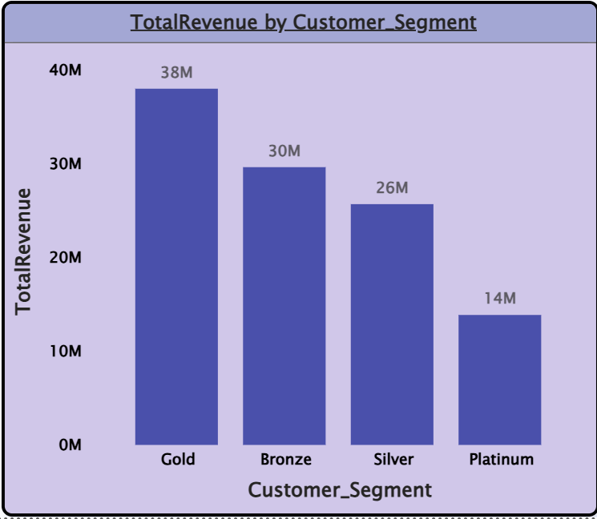
- The majority of customers (86.9K) are in the bronze tier, that generates the revenue (30M).
- The Platinum tier has the fewest customers (1.9K) that generates revenue of 14M only.
- Silver tier has approximately 15.4K customers and contributes ₹26M, indicating strong mid-tier engagement.
- Gold tier has ~9K customers and contributes the highest revenue generator ₹38M, indicating potential for tier growth.
Recommendations:
- Upsell Bronze customers to higher tiers using targeted promotions or bundled offers.
- Retain Platinum customers through loyalty programs, priority service, and personalized offers.
- Convert Silver to Gold/Platinum by incentivizing higher order values and more frequent purchases.
- Analyse Silver tier purchasing patterns to understand why growth is slower than Bronze and implement targeted campaigns.

- Using the DAX functions Calculate and a row iteration DAX function calculate the total sales for the Product Category “Fashion” and delivery type “Shipped from Abroad”. What are the other types of DAX functions you have used in the project?
- Measure for calculating total sales for the Product Category “Fashion” and delivery type “Shipped from Abroad”.
TotalSales_Fashion_Abroad = CALCULATE(SUMX(Orders,Orders[Sale Price]),Orders[Product Category]="Fashion",Orders[Delivery Type]="Shipped from Abroad")
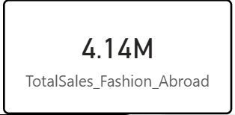

Other DAX Functions used in Project are:

AvgDaysForDeliveredProduct = CALCULATE(AVERAGE(Orders[WaitingTime]),Orders[Status]="Delivered")

AvgQuantity = AVERAGE(Orders[Order Quantity])

CountOfReturnedProducts = COUNTROWS(FILTER(Orders,Orders[Status] = "Returned"))

WaitingTime = DATEDIFF(Orders[OrderDate],Orders[Delivery Date],DAY)

PrevYearSales = CALCULATE([TotalRevenue],SAMEPERIODLASTYEAR(CALENDER[Date]))

TotalUniqueProducts = DISTINCTCOUNT(Orders[Product])

TotalOrderQuantity = SUM(Orders[Order Quantity])

- Wait Times Correlated with Demographics and Care: Explore how average wait times vary across different product categories to optimize scheduling and staffing.

Already calculated Delivery Duration which is the duration between order date and delivery date, and it is same for wait times as well.
Avg_DeliveryDays = AVERAGE(Orders[WaitingTime])
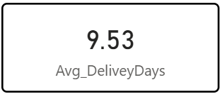
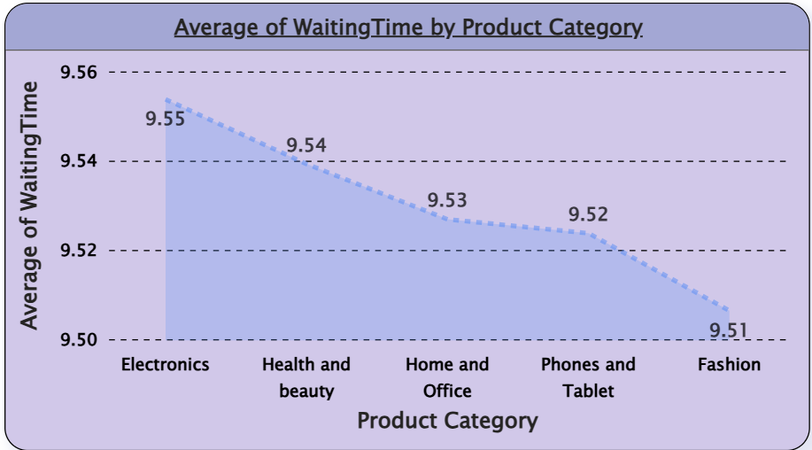
Insight:
- Electronics has the longest average wait time (9.554 days), suggesting that there may be inefficiencies or delays in processing orders in this category.
- Health and Beauty, although slightly higher than Home and Office, still falls into a higher category of wait times compared to others, indicating a potential issue in fulfilment processes for this category.
- Fashion, Phone and Tablets, and Home and Office have relatively closer wait times, though Fashion still has a lower average compared to the others, indicating a more efficient processing system for this category.
Strategies to optimize scheduling and staffing:
- Allocating more staff or optimize fulfilment processes to reduce delays in this Electronics category.
- Ensuring the current staff levels are maintained but be prepared to scale during peak demand periods.
- By leveraging data to forecast high-demand periods (e.g., holidays) and adjust staffing levels to ensure timely order fulfilment across all categories.
- Explore if there is any relationship between the Delivery type and waiting time between ordering and receiving an item.

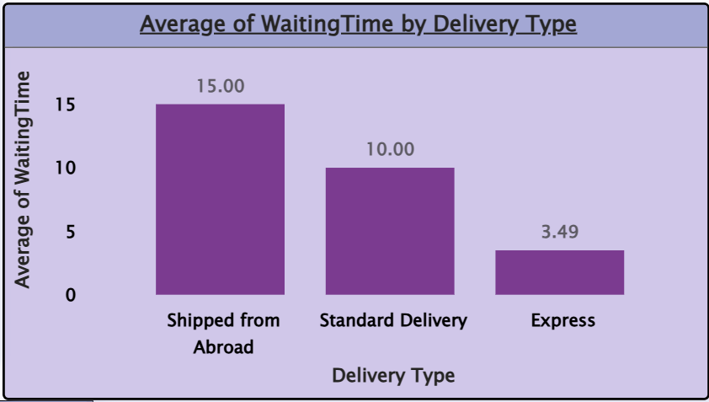
Insights:
- Shipping from Abroad has the highest average wait time (15.0 days), indicating that international shipping or logistics may be causing significant delays. This could be due longer transit times, or limited shipping options.
- Standard Delivery has a moderate wait time of 10.0 days, suggesting that domestic deliveries take a reasonable amount of time but may still have room for improvement.
- Express Delivery has the shortest wait time (~3.5 days), which is ideal for customers who value quick delivery. However, since it’s significantly faster, it might suggest that customers are willing to pay a premium for faster service.

Recommendations:
- Partner with faster international carriers to reduce the long wait times for Shipped from Abroad.
- Improve customs clearance processes to minimize delays in international shipments.
- Prioritize Express Delivery during peak times to maintain the quick 5-day delivery window.
- Adjust staffing levels based on demand for different delivery types, particularly during peak seasons, to avoid delays.

- Is there any relationship between shipping charges and product type?

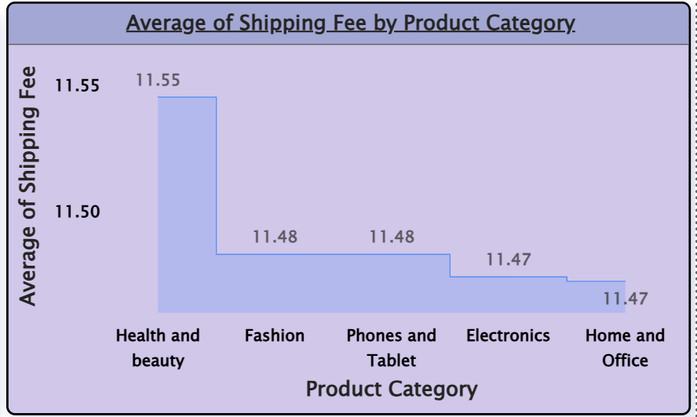

Insights and Recommendations:
- The shipping charges for all the product types are almost identical, ranging from 11.47 to 11.55. This indicates that the shipping charges do not vary significantly across these categories in our data.
- This could imply that the company uses a standardized shipping fee regardless of the product type, which is common in e-commerce businesses where flat rate shipping fees are applied for convenience.
- The minimal difference suggests that the shipping fees are either fixed or determined by factors other than the product type, such as the size, weight, or delivery location, rather than the product's category.

- Come up with strategies to decrease the low rating orders after analyzing different factors like waiting time, shipping type, unit price, etc.

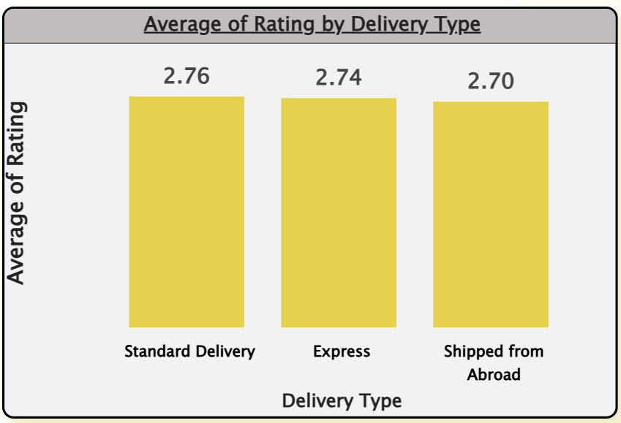
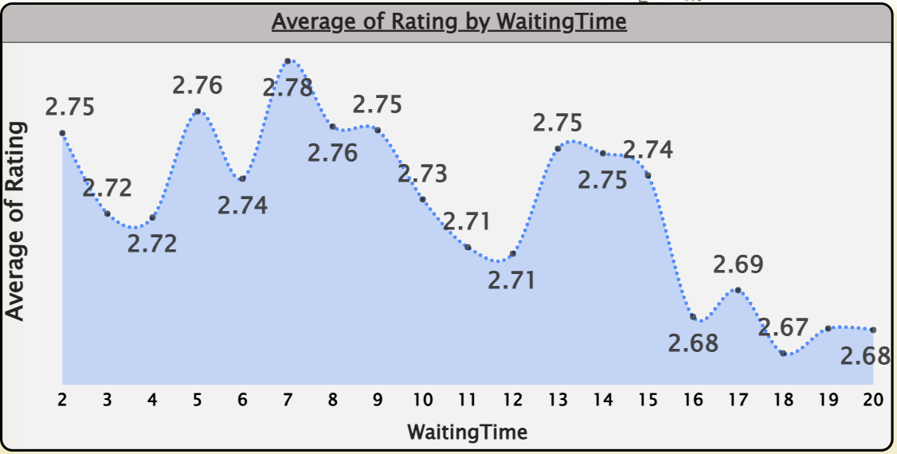

Insights:
- Standard Delivery has the highest average rating (~2.76), slightly better than other modes.
- Express Delivery performs close to Standard, indicating consistent service quality.
- Shipped from Abroad has the lowest rating (~2.70), showing room for improvement.
- Overall ratings are tightly grouped, suggesting delivery type impacts ratings but not drastically.
- Ratings are highest when waiting time is short to moderate (around 5–8 days).
- Ratings decline noticeably as waiting time increases beyond ~12–15 days.
- Very long waiting times (16–20 days) consistently result in the lowest ratings.
- Customer satisfaction is clearly sensitive to delivery delays.
Recommendations:
- Maintain current service standards for Standard and Express deliveries.
- Improve communication and tracking for international shipments.
- Review delays, packaging, or customs issues affecting “Shipped from Abroad”.
- Set clear delivery expectations for longer waiting periods.
- Optimize logistics to reduce delays beyond 12 days.
- Introduce alerts or proactive updates for delayed orders.
- Offer incentives (discounts/refunds) for extended delivery times to retain satisfaction

- Using the time intelligence DAX function, create a table to compare each month’s sales with the previous year’s same month’s total sales. So there will be four columns in the output year, month, total sales, previous_years_sales.

Measure for Previous Year sales:
PrevYearSales = CALCULATE([TotalRevenue],SAMEPERIODLASTYEAR(CALENDER[Date]))

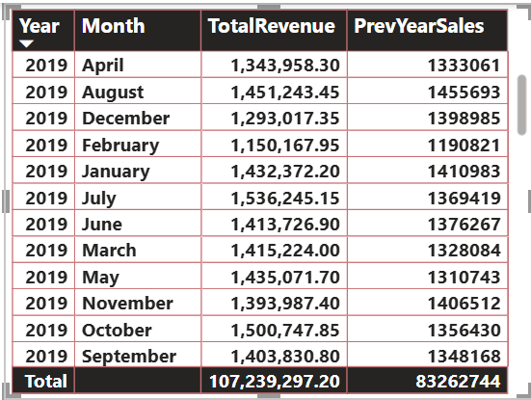

- What do you understand by PowerBI gateway? What are its use cases?
- Power BI Gateway is a bridge between on-premises data sources and Power BI in the cloud. It allows to schedule refreshes, connect to local databases, and ensure that Power BI reports are up-to-date.
Use Cases of Power BI Gateway:
  - On-Premises Data Integration: For businesses with on-premises databases, the gateway enables seamless data transfer.
  - Real-Time Data: Power BI Gateway allows you to provide real-time analytics.
  - Security: Ensures secure data transfer between on-premises and cloud services.
  - Hybrid Data Scenarios: Organizations can manage data both in the cloud and on-premises. The gateway supports hybrid setups, making it easier to analyse data across different environments.
  - Integration with Other Services: It can be used with other Microsoft services like Azure Analysis Services and SQL Server Analysis Services, allowing for a seamless integration of analytics solutions.

- How would you approach this problem, if the objective and subjective questions weren't given?

If objective and subjective questions weren't provided in the given problem statement, here’s how I would approach the task:
Step 1) Data Exploration and Cleaning:
I will start by exploring the dataset. Check the summary statistics to understand key trends. Look for missing values and handle them appropriately. Clean the data by standardizing categories and correcting any inconsistencies.
Step 2) Business Objective:
Focusing on the objectives like boosting sales, optimizing delivery times, improving customer satisfaction, or enhancing product offerings and then identify the areas where business can improve its performance.
Step 3) Key Metrics:
Now by focusing on some key metrics like total sales, customer satisfaction (ratings), product performance, and delivery efficiency that will help overall business and identify areas for improvement.
Step 4) Dashboard:
Finally, creating visualizations that allow stakeholders to interact with the data. By designing the dashboards that provide insights into sales by product, region, and time. This will help the team drill down into the data and make informed decisions.

